MACHINE LEARNING-24ADI003
EXP-1 INTRODUCTION TO PYTHON LIBRARIES AND DATASET PREPROCESSING
SCENARIO 1: E-commerce Sales Data
Analyze a sample e-commerce dataset to understand product categories, sales trends, and missing information.
Dataset (Kaggle – Public): https://www.kaggle.com/datasets/carrie1/ecommerce-data
IN-LAB TASKS:
· Import necessary Python libraries.
· Load the dataset into a Pandas DataFrame.
· Inspect dataset using head (), tail (), info (), and describe ().
· Check for missing values.
· Visualize sales per product using bar and line charts.
OUTPUT:
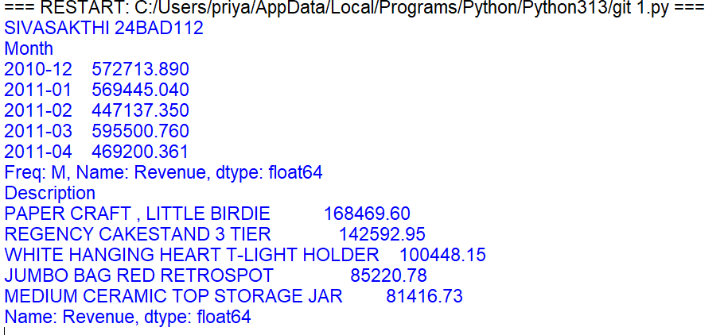
BAR CHARTS AND LINE CHARTS:
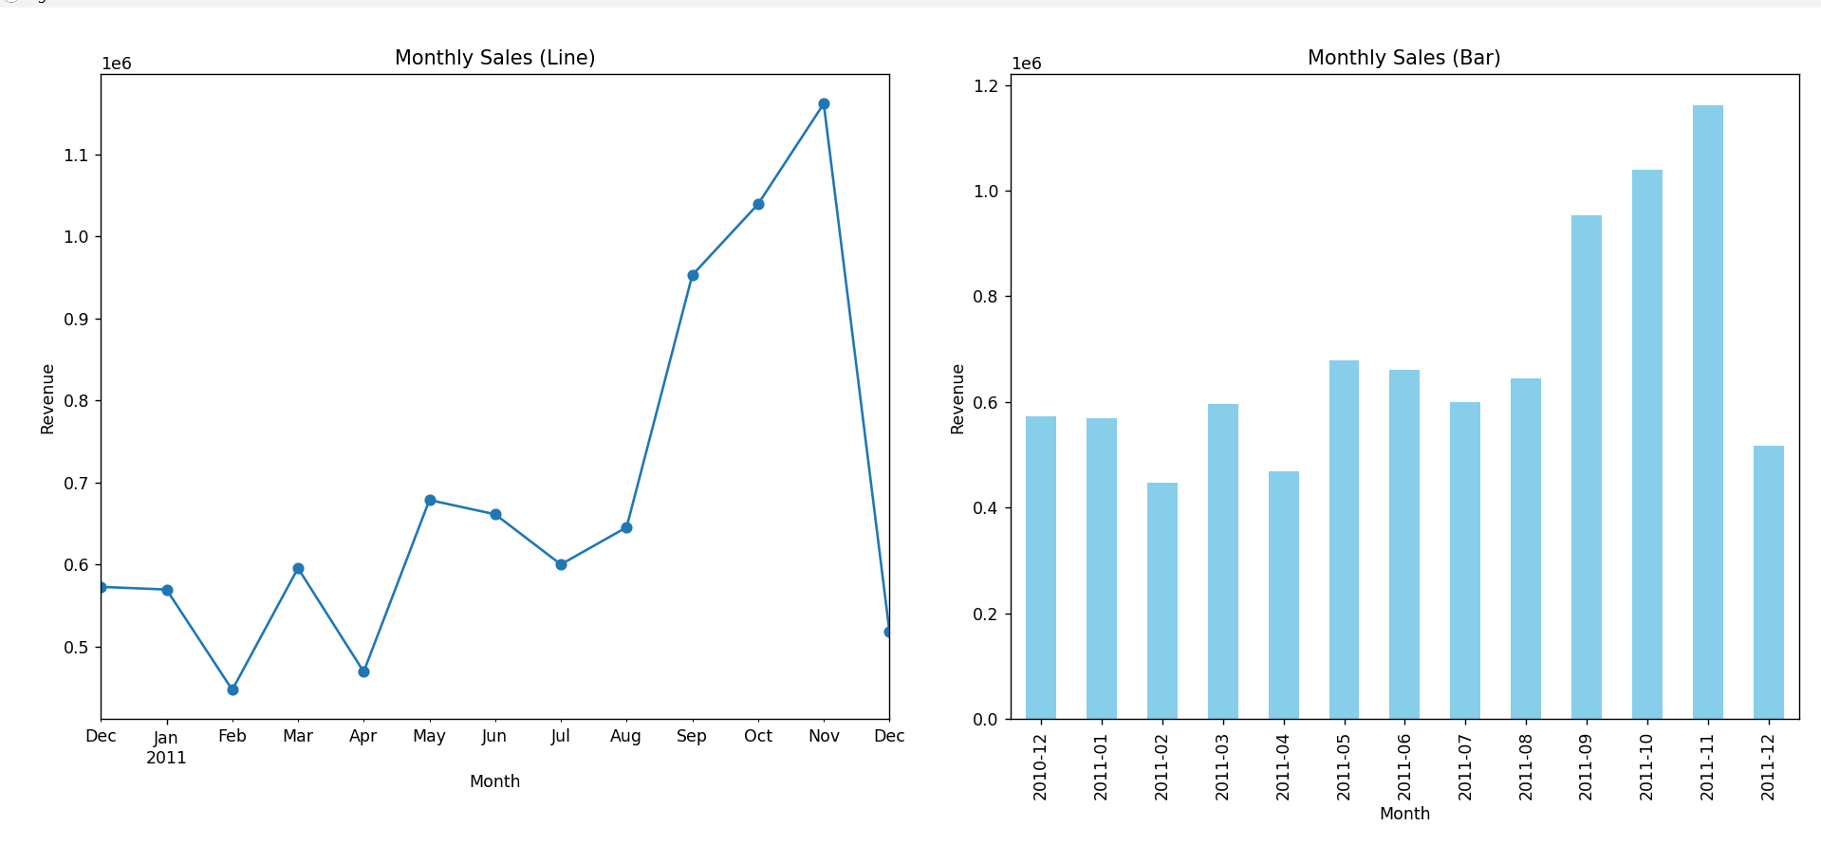
SCENARIO 2: Hospital Patient Records
Examine a patient dataset to identify missing health metrics and visualize distributions.
Dataset (Kaggle – Public): https://www.kaggle.com/datasets/uciml/pima-indians-diabetes-database
IN-LAB TASKS:
· Load the dataset into Pandas.
· Explore data structure and missing values.
· Visualize glucose levels and age distribution using histograms and boxplots.
· Identify patterns in health metrics.
OUTPUT:
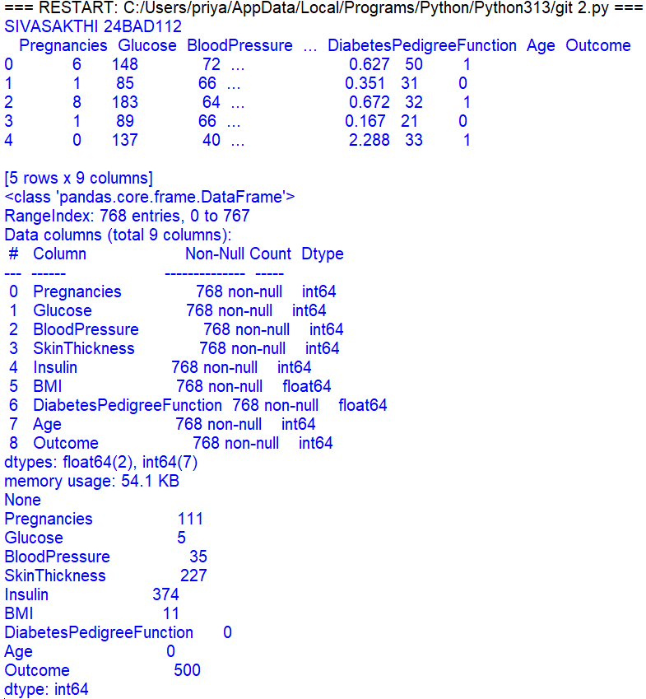
BOXPLOTS:
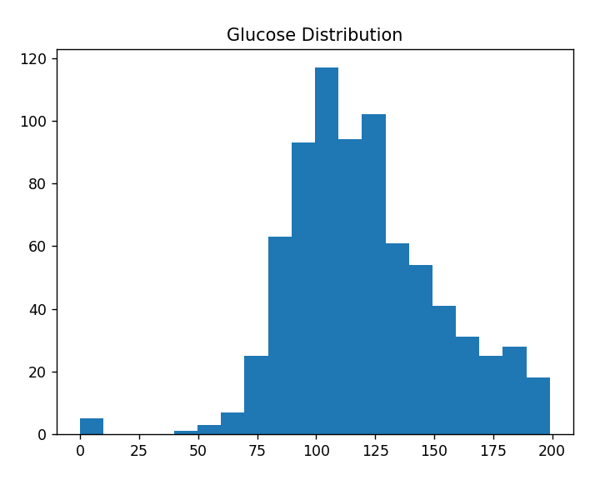
HISTOGRAM:
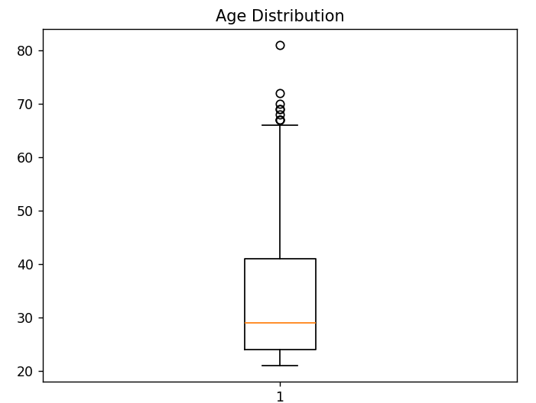

SCENARIO 3: Housing Dataset
Investigate a housing dataset for missing features and relationships between house attributes.
Dataset (Kaggle – Public): https://www.kaggle.com/datasets/harishkumardatalab/housing-price-prediction
IN-LAB TASKS:
· Load the dataset and inspect columns.
· Detect and summarize missing values.
· Visualize correlations between numerical features using scatter plots and heatmaps.
· Interpret trends for price prediction
OUTPUT:
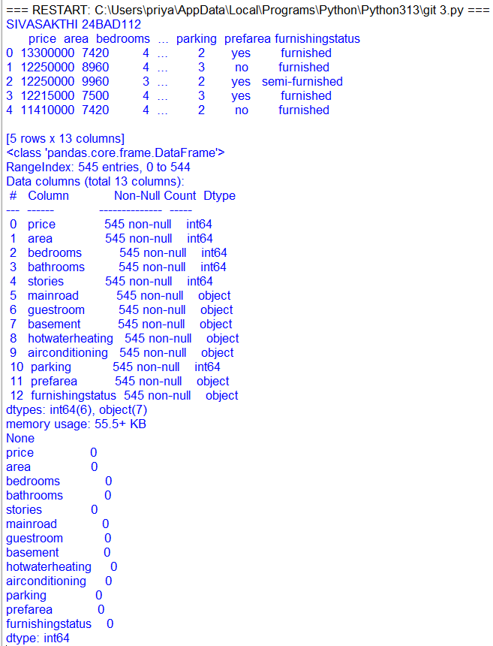
SCATTERPLOTS:
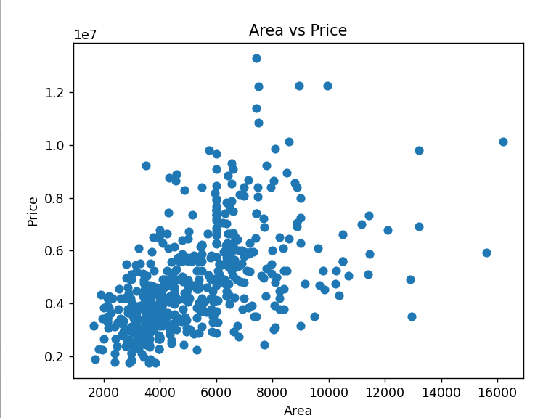
HEATMAPS:
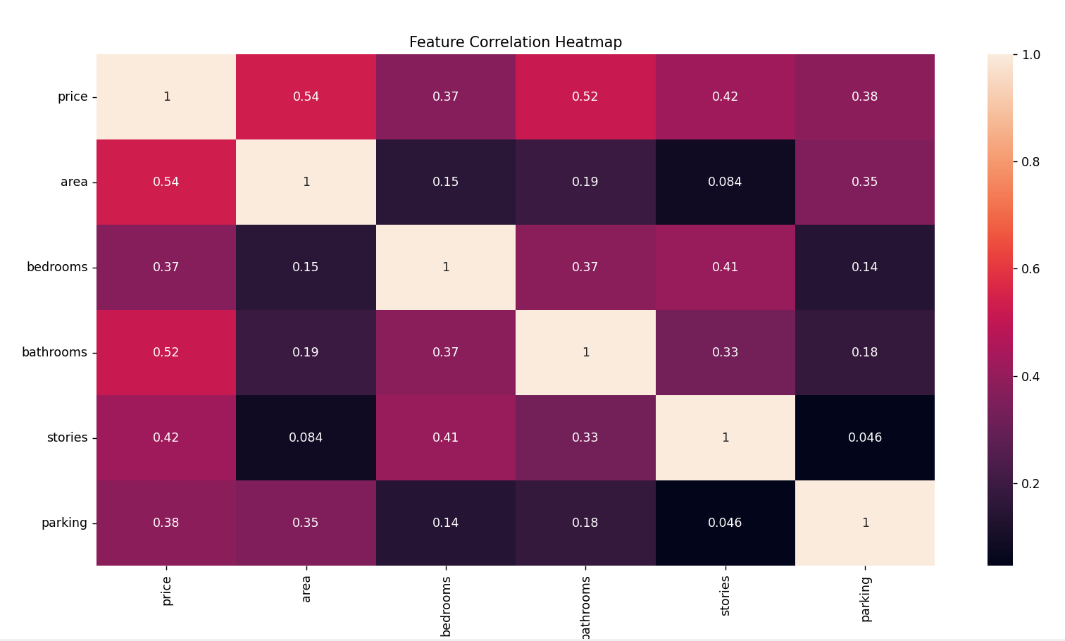
SCENARIO 4: Banking Customer Data
Analyze banking data to detect missing account information and understand customer demographics.
Dataset (Kaggle – Public):
https://www.kaggle.com/datasets/imakash3011/customer-personality-analysis
IN-LAB TASKS:
· Import dataset into Pandas.
· Examine structure, null values, and column types.
· Visualize age, income, and spending patterns using bar and box plots.
· Summarize insights from visualizations
OUTPUT:
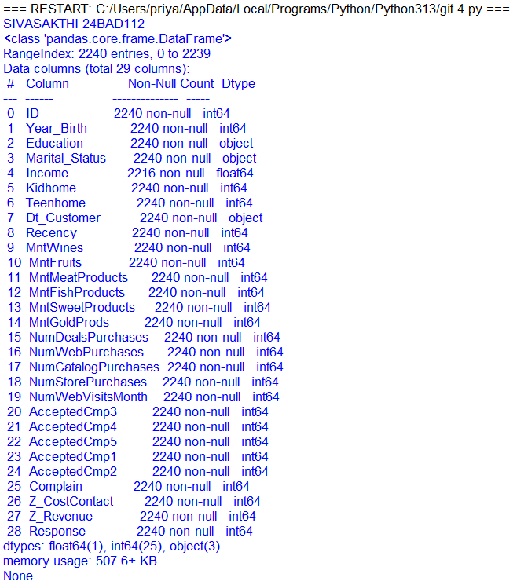
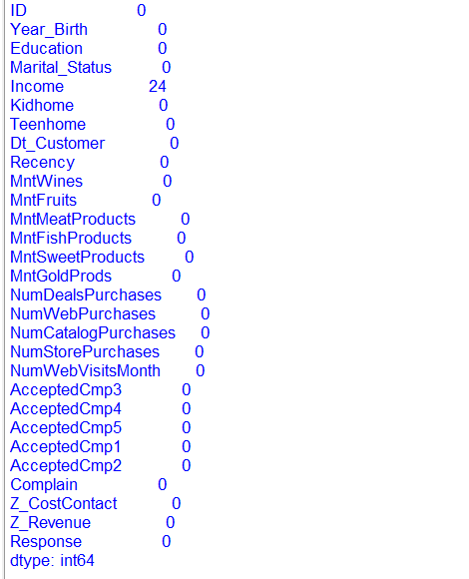
BAR PLOTS:
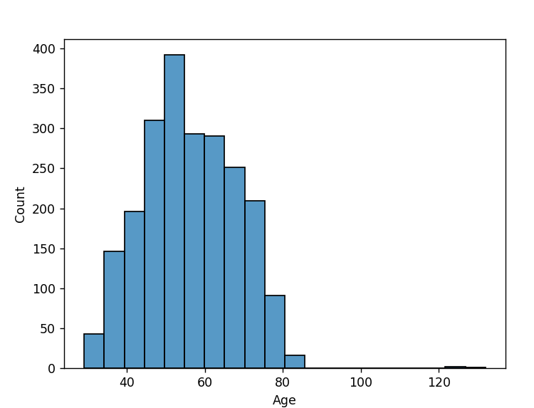
BOX PLOTS:
